

**SERVICES**

**The Praetors**

CONTENTS

1 PROGRESSIVE WEB APP DEVELOPMENT 2

2 WEB APPLICATION DEVELOPMENT 12

3 ECOMMERCE DEVELOPMENT 21

# PROGRESSIVE WEB APP DEVELOPMENT

**META TITLE**: Progressive Web App Development Company | The Praetors

**META DESCRIPTION**: Discover top-notch progressive web app development services. Our expert team combines cutting-edge technology with unparalleled expertise to deliver innovative solutions.

**URL**:

**[BANNER 1]**

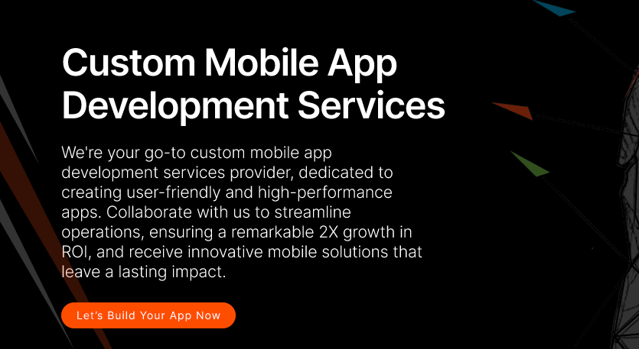

**Top Progressive Web App Development Company**

As a premier custom PWA development company in the USA, The Praetors excels in creating swift, scalable, and high-performing web applications that enhance conversions and ensure effortless access for your clientele. With our innovative approach, we guarantee exceptional user experiences, even in low-connectivity settings. Count on us for top-quality, feature-rich PWAs that cater to diverse devices and surpass industry standards.

**[LET’S BUILD YOUR SOFTWARE NOW]**

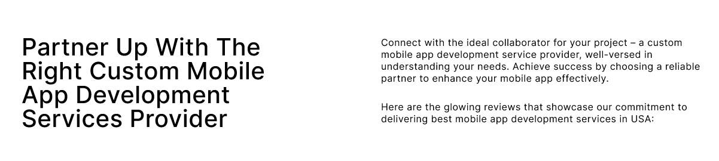

**Dynamic Progressive Web App Development Solutions For Progressive Results!**

Combining cutting-edge progressive web app technology with our seasoned mobile and web development expertise, we create robust solutions that redefine user experiences. Renowned for our top-notch custom progressive web app development services, we blend technical prowess with a relentless focus on delivering impactful experiences. Expect feature-rich solutions that exceed expectations, empowering you to achieve your goals seamlessly.

Trust us to bring your vision to life in the digital realm, ensuring scalability, reliability, and innovation every step of the way.

Top of Form

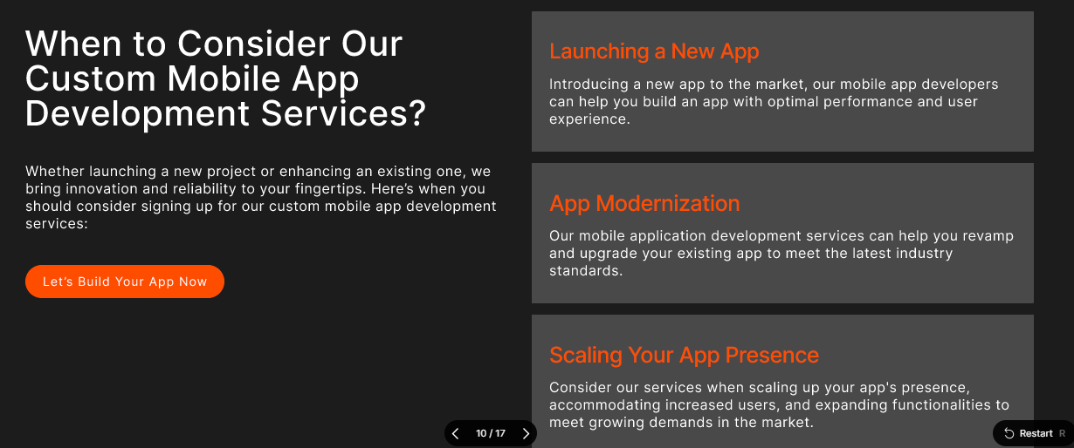

**Seamless Performance, Limitless Possibilities: Explore Our Progregressive Web App Development**

With our tech-powered progressive web design and developmeny, we specialize in creating sleek and robust designs tailored to your business objectives. Our focus is on delivering fast, reliable, and visually appealing progressive web apps that perfectly reflect your brand identity. With our expertise, we ensure that your PWA serves as a powerful tool for growth and scalability, meeting the highest standards of performance and user experience.

Trust us to provide comprehensive solutions that strengthen your online presence and drive success in the digital world.Top of Form

|  |  |
| --- | --- |
| **Multi-Platform Accessibility** | Our apps are meticulously crafted to function seamlessly across various platforms, ensuring a consistent user experience regardless of the device or operating system used. |
| **Native App Experience** | Our apps provide users with a native-like experience, boasting smooth performance and intuitive interfaces akin to traditional native applications. |
| **Technical Maintenance & Support** | We offer comprehensive technical maintenance and support services to ensure that your app remains updated, secure, and fully operational, providing peace of mind to both you and your users. |

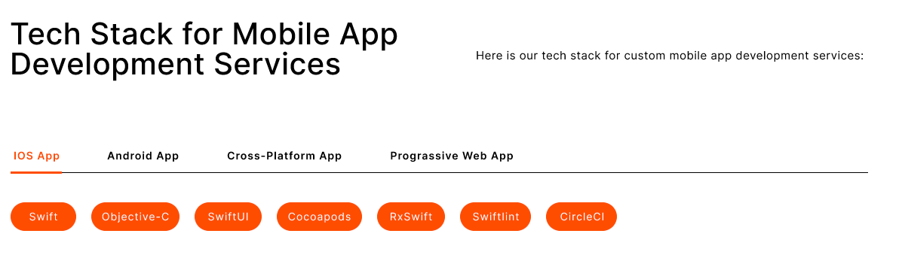

**Responsive, Reliable and Revolutionary PWA Services - Driven by Dynamic Tech Stacks**

We offer custom progressive web app development powered by state-of-the-art technology.

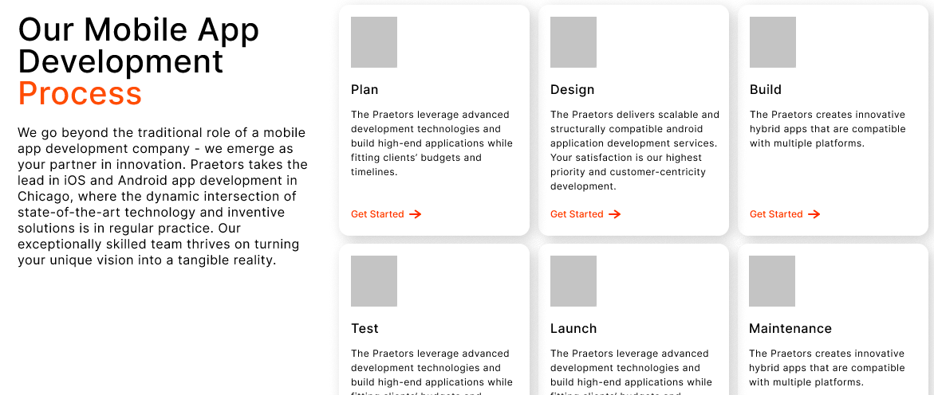

**Discover Our Methodical PWA Development Process**

Our progressive web app developers streamline a process that is carefully structured, with a primary focus on personalized user experiences and the creation of exceptionally efficient solutions. Through our comprehensive range of services, we establish a transparent and dependable partnership, ensuring the delivery of impactful and groundbreaking software solutions. With our experienced guidance and never-ending dedication, you can trust us to navigate every aspect of the journey professionally and precisely, driving forward transformative results for your business.

|  |  |
| --- | --- |
| **Discovery** | We begin by understanding your needs and goals and gathering essential information to lay the foundation for our collaboration. |
| **Planning** | With a clear understanding, we develop a detailed plan outlining the scope, timeline, and resources required for the project. |
| **Design** | Our team creates intuitive, user-friendly designs, ensuring the PWA apps align seamlessly with your vision and objectives. |
| **Development** | Our skilled progressive web app developers bring the designs to life, meticulously coding and building the apps according to the outlined specifications. |
| **Testing** | Rigorous testing procedures are conducted to identify and resolve any issues, ensuring the apps meet high quality and functionality standards. |
| **Launch** | Once thoroughly tested and approved, we deploy the apps, providing comprehensive support and guidance to ensure a smooth transition and optimal performance. |

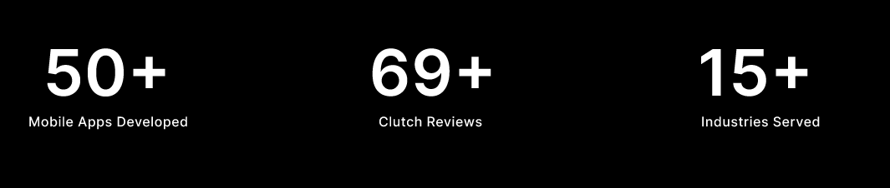

|  |  |  |
| --- | --- | --- |
| **2+**  **Decades of Experience** | **137K+**  **Clients Globally** | **350K+**  **Digital Products Delivered** |

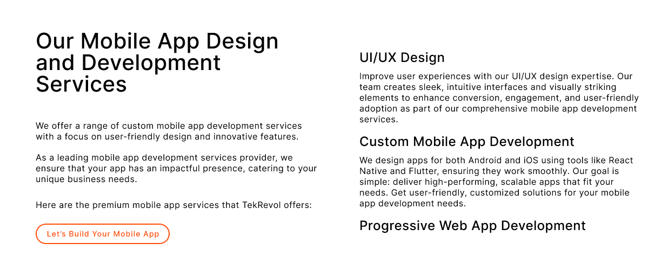

**Our Custom Progressive Web App Development Services**

The Praetors offers sophisticated progressive web app development solutions for businesses of all sizes and types. Our team specializes in creating bespoke PWAs that align seamlessly with your business objectives.

Utilizing state-of-the-art technologies, we deliver user-centric web applications that provide exceptional performance and user experiences. Stay ahead of the curve in the competitive online landscape with our tailored web development services.

Experience the professionalism and expertise of our team as we transform your digital vision into reality.

|  |  |
| --- | --- |
| **Customized PWA Solutions**  We customize progressive web apps to meet your specific business needs and goals. From navigation to payment processing to push notifications, our experienced developers configure each PWA for an optimal user experience in your industry. | **Migration To PWA**  Moving your existing website or mobile app to a progressive web app can boost its capabilities and performance. Our migration process carefully transfers over your content, design, and features while integrating cutting-edge PWA technologies. Users enjoy all the benefits of an app with none of the download hassles. |
| **Search-Engine Friendly**  Progressive web apps are designed to be completely search-engine optimized from the start. We ensure your PWA content is easily discoverable, indexed properly by search engines, and that each page has descriptive meta information. This means more qualified traffic and higher conversion rates from organic search results. | **Advanced Development Approach**  Our team employs modern development methodologies and practices to deliver top-quality progressive web apps. We follow an agile workflow, utilize modular code design, optimize for accessibility and speed, and constantly iterate based on real user feedback. You get an innovative solution built for the future with integrated monitoring and continuous improvement. |

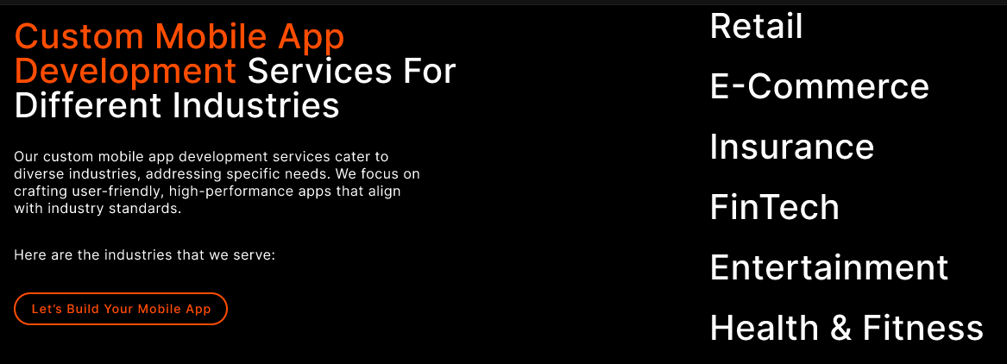

**From Healthcare to Finance: Our Progressive Web App Development Expertise Knows No Bounds!**

Whether your business is in healthcare, finance, e-commerce or another sector, our progressive web app development team has the expertise to create an effective custom PWA solution. We have extensive experience delivering feature-rich, performant PWA solutions for companies across many industries. Our developers understand the unique technical and user-experience challenges that businesses face in highly-regulated fields like healthcare and finance.

With a deep understanding of industry compliance and data security best practices, our progressive web app developers ensure your PWA complies with all necessary requirements while still providing an engaging user experience. Through ongoing support and maintenance, your PWA will continue to meet your evolving business needs for years to come.

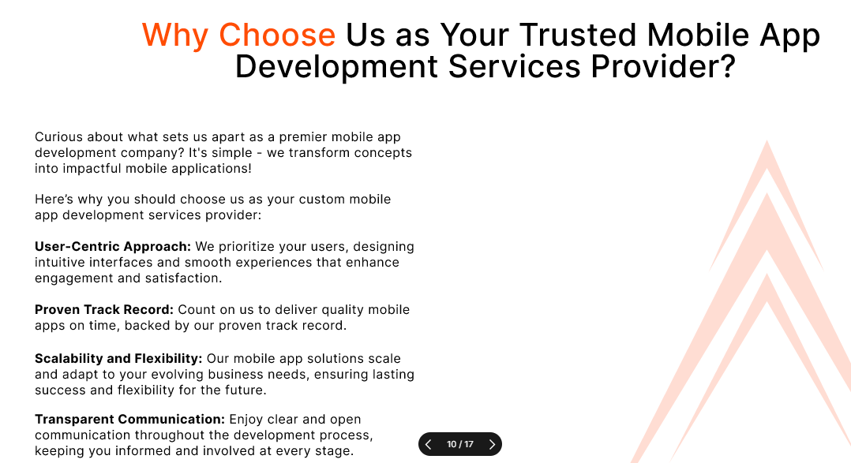

**Our Mission - Empowering Your Journey with Innovation & Integrity**

At our core, our mission is to empower businesses with transformative digital solutions that drive growth and innovation. As a top progresive web app development company in the US, we are dedicated to leveraging our expertise and creativity to craft bespoke software that meets each client's unique needs and challenges.

Our commitment to excellence guides every aspect of our work, from initial concept to final delivery. We prioritize transparency, communication, and collaboration to ensure that our clients are always informed and involved throughout the progressive web app development process. By fostering strong partnerships built on trust and reliability, we aim to become the go-to digital partner for businesses seeking to thrive in today’s competitive landscape.

Our mission is not just to meet expectations, but to exceed them, delivering tangible results and measurable impact for our clients. With a focus on continuous improvement and adaptation to emerging technologies, we strive to stay at the forefront of the industry, driving innovation and pushing boundaries to help our clients succeed in their digital endeavors.

Top of Form

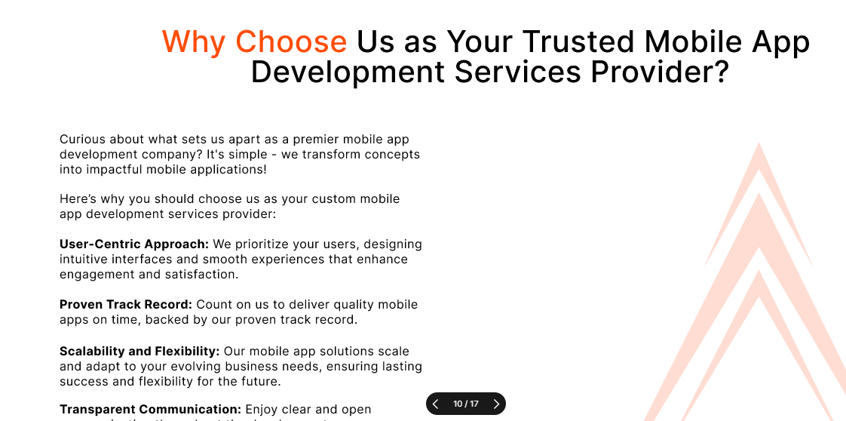

**What Makes The Praetors Your Ideal Progressive Web Application Development Company?**

With over two decades of experience in the indutry, The Praetors have established a reputation as a premier choice for progressive web application development through our deep technical expertise and track record of successful projects.

Our talented team approaches each client solution with care, thoroughness and an unmatched understanding of PWA frameworks, standards and runtime capabilities. By prioritizing architectural quality, performance optimization and accessibility, we develop robust, feature-rich apps that exceed user expectations.

Clients also benefit from our integrated development methodologies, diligent project management and responsive long-term support.

Whether you need to migrate an existing solution or build a new customer-facing platform, our consultative process ensures projects are seamlessly scoped and delivered to achieve your strategic business goals.

|  |  |
| --- | --- |
| **Quality Products** | We’re all about delivering top-notch stuff, making sure it's spot-on and totally reliable, so you're always happy with what you get. |
| **Robust Development** | When we build a custom PWA app, we make sure it's super tough and can handle whatever you need it to do. That's how we roll! |
| **Latest Tech Stack** | We’re all about using the coolest, newest tech to make awesome custom apps that's ahead of the game and helps your business grow. |
| **Complete Transparency** | We’re open books here, keeping you in the loop every step of the way so you know exactly what's happening with your custom progressive web app development project. No secrets here! |

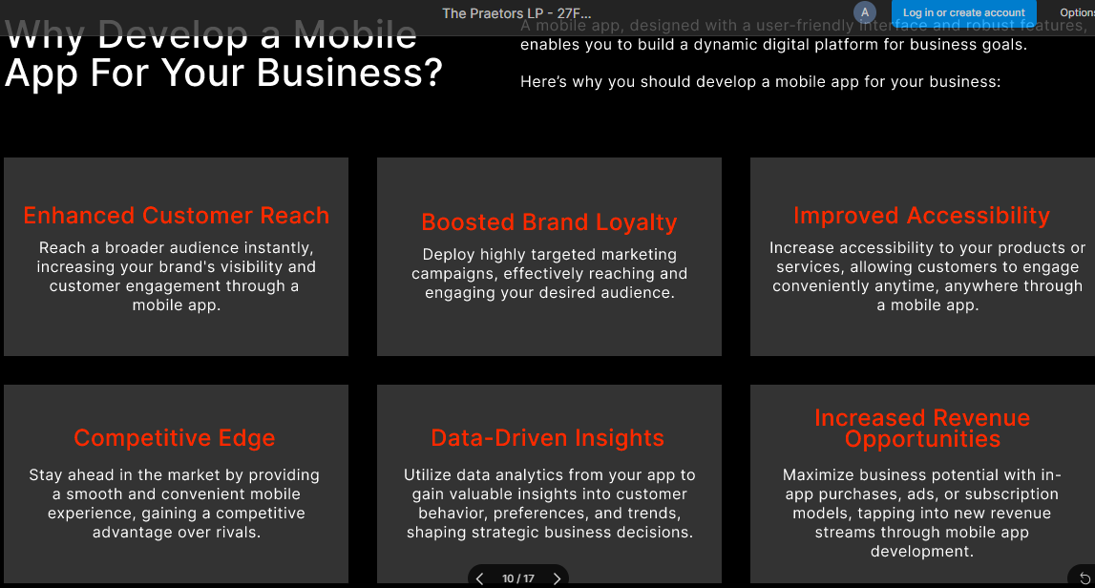

**Why Opt For Progressive Web App Development For Your Business?**

There are many compelling reasons to choose progressive web app development for your business. PWAs loading quickly on any device or network condition, have native-like functionality, and are easy to update and install. They keep users engaged with a smooth app-like experience while eliminating the downsides of mobile apps.

Going with PWAs also provides more visibility in search engines and accessibility globally. Progressive web apps future-proof your online presence and drive stronger customer acquisition, retention and revenue over the long run.

|  |  |  |
| --- | --- | --- |
| **Cross-Platform Compatibility**  Progressive web apps can be accessed on any device via a URL, without requiring native app downloads or app store approvals. This cross-platform reach allows your app to work seamlessly across different operating systems. | **Speed and Performance**  Optimized code, efficient resource caching, and service workers help progressive web apps load instantly even on slow mobile connections. Automatic caching of resources and static assets further enhances responsiveness and provides fast performance for users. | **Offline Functionality**  Service worker caching allows progressive web apps to store necessary assets and response data so that previously visited pages and core functionality can still be accessed offline without an internet connection. |
| **Push Notifications**  Engage users and boost re-engagement with relevant, timely push notifications. These messages are easy to set up through service workers and provide an effective way to deliver important updates and prompts to users through their installed PWA. | **App-Like Experience**  Progressive web apps bring native app interfaces like splash screens, homescreen icons, and app shells to deliver an app-centric experience right within the browser. Users gain the power and convenience of a dedicated application. | **Security**  Progressive web apps integrate natively with existing security systems and protocols to ensure protection both on the user and server-side. Additional defenses like HTTPS, SSL encryption, and credential management provide multiple layers of security. |

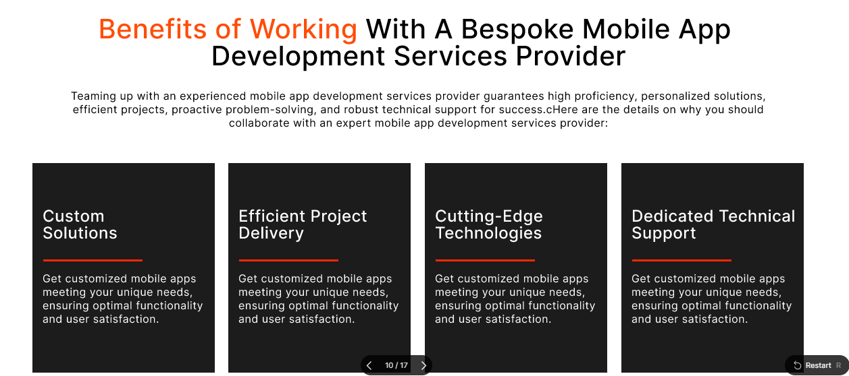

**Benefits of Working With A Professional & Reliable Custom PWA Development Company**

Partnering with The Praetors offers numerous benefits. From expert guidance and streamlined communication to high-quality solutions and timely delivery, you can trust in our expertise to enhance your business operations and drive growth in today’s competitive market landscape.

|  |  |  |  |
| --- | --- | --- | --- |
| **Future-Ready Products**  We're all about staying ahead of the game, crafting innovative solutions that'll tackle tomorrow's challenges head-on. | **Dedicated Team**  Count on us to bring your ideas to life! Our PWA developers are dedicated, skilled, and ready to make your vision a reality. | **Customer Experience**  We’re here to make your experience seamless and personalized, tailored just for you and your success. | **Satisfaction Guarantee**  Your satisfaction is our top priority. We're committed to making sure you're thrilled with the results. |

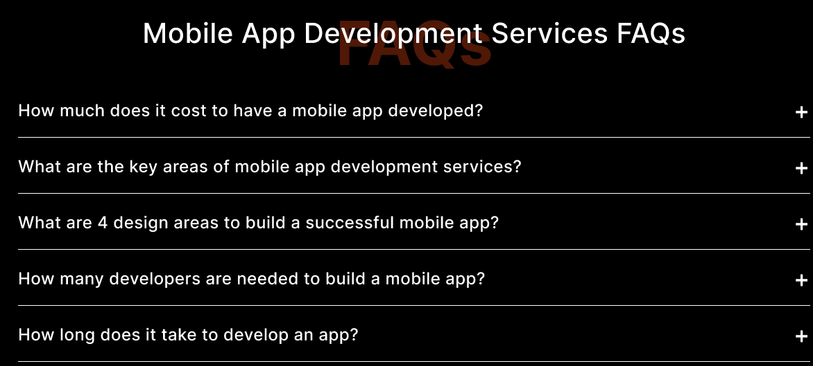

**Progressive Web App Development Services FAQs**

**What is a Progressive Web App (PWA)?**

A PWA is a type of web application that utilizes modern web technologies to provide a mobile app-like experience to users.

**How does a PWA differ from a native app?**

PWAs are accessed through a web browser and do not require installation from an app store, while native apps are installed directly on the device.

**Are PWAs compatible with all devices and browsers?**

Yes, PWAs are designed to work across various devices and browsers, providing a consistent user experience.

**Can PWAs work offline?**

Yes, PWAs can function offline or with limited connectivity, allowing users to access content and features even without an internet connection.

**What are the advantages of choosing custom progressive web app development?**

Some benefits of PWA development include improved performance, increased engagement, offline functionality, and cost-effectiveness compared to native app development.

**How secure are PWAs?**

PWAs adhere to web security standards and protocols, ensuring data privacy and security for users, similar to traditional web applications.

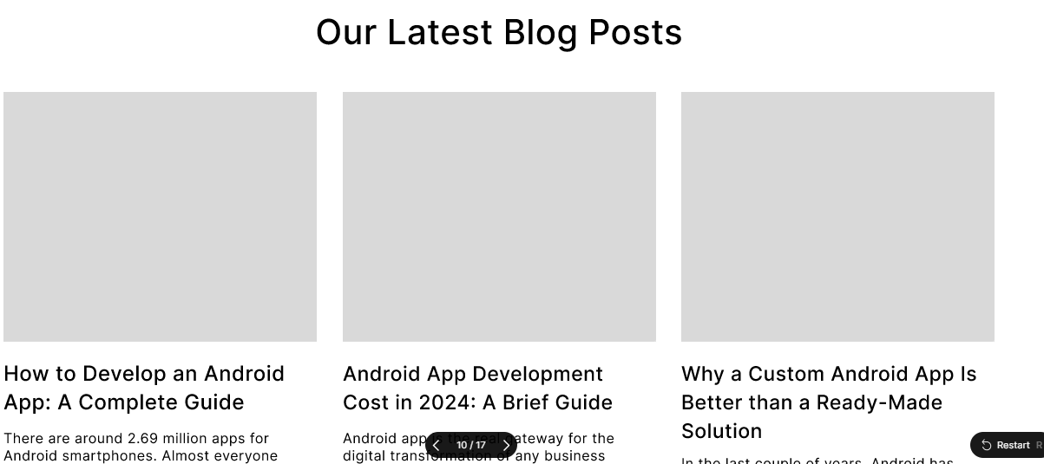

**READ OUR LATEST BLOG**

**[BLOGS HERE]**

# WEB APPLICATION DEVELOPMENT

**META TITLE**: Custom Web App Development | The Praetors

**META DESCRIPTION**: We provide custom web application development solutions for all business needs. With a focus on performance, our developers create feature-rich, responsive web apps!

**URL**:



**Custom Web Application Development Services**

Transform your vision into reality with The Praetors' specialized custom web application development services. Our experienced developers thrive on the challenge of crafting innovative, personally tailored digital solutions. Through collaborative design and iterative delivery, we sculpt precisely what you envision - powerful platforms with streamlined workflows, intelligent integrations and engaging interfaces. Built on a foundation of security, scalability and performance, our custom solutions empower users while boosting key metrics for your business.



**Partner with Custom Web App Development Company for Robust, Performance-Driven Products!**

Looking to take your web presence and digital offerings to the next level? Partner with The Praetors, a leading design and development firm in the US for industry-leading web application development services. With a deep understanding of programming best practices and technologies, we craft robust, high-performing solutions perfectly tailored to your business needs. Through rigorous testing and optimization, our developers ensure your app loads fast, works seamlessly across devices and stands up to heavy usage.

You'll also gain a dedicated team providing long-term support - continuously innovating and helping your online solutions and profile evolve as your company grows.



**Explore Our Expert Web Application Development To Transform Data into Decisions with Insight-Yielding Interfaces**

Leverage The Praetors’ extensive web development expertise to transform data into strategic business advantages. Our custom applications integrate seamlessly with your existing systems to aggregate and analyze complex information flows. With finely-tuned interfaces built on progressive web technologies, you gain insightful real-time dashboards and visualizations crafted for your specific reporting and decision-making needs.

Whether you require automated forecasts, sales performance overviews or operational metrics, we design personalized data-driven solutions that fuel smarter choices and maximize every opportunity for growth.

|  |  |
| --- | --- |
| **Insightful Data Visualizations and Reporting** | Our developers craft customized interfaces and dashboards that transform raw numbers into clear, actionable visuals. Dynamic charts, scorecards and heat maps provide intuitive overviews to help monitor KPIs, spot trends and pinpoint areas for improvement. |
| **Real-Time Data Integration** | We integrate seamlessly with your existing databases and systems to aggregate both internal and external data streams into your custom application. This unified platform ensures you have powerful real-time insights at your fingertips for informed, timely decisions. |
| **Predictive Analytics Capabilities** | Leveraging machine learning techniques, our apps process past performance patterns to generate accurate automated forecasts of future outcomes. Sales projections, inventory needs and other predictive insights give you strategic guidance to proactively shape business results. |



**Innovative Web Application Development, Driven by Dynamic Tech Stacks**

We offer custom web apps powered by state-of-the-art technology.



**Our Seamless Web Application Development Services Process**

Our seamless development process starts with thorough discovery and analysis to understand your unique needs and goals. Our designers then craft optimized solutions through interactive prototyping and testing. Solid coding practices ensure robust, scalable products delivered through an iterative approach. On-time, on-budget delivery is complemented by ongoing support, enabling your app to continually meet evolving business demands.

|  |  |
| --- | --- |
| **Discovery** | We begin by understanding your needs and goals and gathering essential information to lay the foundation for our collaboration. |
| **Planning** | With a clear understanding, we develop a detailed plan outlining the scope, timeline, and resources required for the project. |
| **Design** | Our team creates intuitive, user-friendly designs, ensuring the app aligns seamlessly with your vision and objectives. |
| **Development** | Our skilled team of custom developers brings the designs to life, meticulously coding and building the app according to the outlined specifications. |
| **Testing** | Rigorous testing procedures are conducted to identify and resolve any issues, ensuring the app meets high standards of quality and functionality. |
| **Launch** | Once thoroughly tested and approved, we deploy the application, providing comprehensive support and guidance to ensure a smooth transition and optimal performance. |



|  |  |  |
| --- | --- | --- |
| **2+**  **Decades of Experience** | **137K+**  **Clients Globally** | **350K+**  **Digital Products Delivered** |



**Explore Our Game-Changing Web Application Development Services**

Are you ready to substantially boost business results with a tailored web application? Explore our premium development services. Whether you require an e-commerce solution, HR portal or custom software, our experts will seamlessly transform your concepts into polished, top-performing digital products through dedicated agile methodologies.

Contact us today to discuss how we can help propel your organization to the next level through advanced, securely-built web solutions.

|  |  |
| --- | --- |
| **Full Stack Development**  Our expert full stack developers are equipped to design, develop and deploy complete web application solutions from front end to back end. They leverage the right tools and technologies to craft systems with optimized performance, scalability, functionality and intuitive UX. You gain a single source for fully-integrated, seamlessly working apps. | **API Development & Integration**  We expertly design and build custom, scalable RESTful APIs to enable efficient data exchange between your applications and systems. Whether migrating a legacy system or developing a new one, our rock-solid, standardized APIs facilitate fast and simple integration. API-first solutions connectivity is seamless. |
| **Mobile-Responsive Designs**  All design aspects automatically reformat content and interface elements to suit any device or orientation. Users enjoy a native app-like experience on phones and tablets. Our responsive frameworks make content perfectly readable on varied screens through fluid, grid-based layouts optimized for touch. | **DevOps & CI/CD**  Our DevOps professionals implement infrastructure automation, version control, testing, security and monitoring tools to support continuous delivery pipelines. Automated build-test-deploy processes get updates to users rapidly while maintaining quality and stability. Developers stay focused and productive. |



**Ultimate Web App Development Solutions Specific For Every Industry**

Whether you operate in healthcare, finance, retail, government or another sector, our expert team provides ultimate custom web app development solutions tailored specifically for your industry's unique needs and regulatory landscape. Leveraging deep experience building solutions for various verticals, we craft secure, fully-compliant digital tools optimized for your workflows and business goals.



**Our Mission - Empowering Your Journey with Innovation & Integrity**

At our core, our mission is to empower businesses with transformative digital solutions that drive growth and innovation. We are dedicated to leveraging our expertise and creativity to craft bespoke digital products that meet the unique needs and challenges of each client.

Our commitment to excellence guides every aspect of our work, from initial concept to final delivery. We prioritize transparency, communication, and collaboration to ensure that our clients are always informed and involved throughout the web application development process. By fostering strong partnerships built on trust and reliability, we aim to become the go-to digital partner for businesses seeking to thrive in today’s competitive landscape.

Our mission is not just to meet expectations, but to exceed them, delivering tangible results and measurable impact for our clients. With a focus on continuous improvement and adaptation to emerging technologies, we strive to stay at the forefront of the industry, driving innovation and pushing boundaries to help our clients succeed in their digital endeavors.



**Unlock the Power of Robust Web Application Development with The Praetors**

When you partner with The Praetors, a leading and reliable web application development company in the US, you’re selecting a seasoned team of experts poised to transform your concepts into successful applications.

We commence by attentively listening to your requirements, ensuring a thorough comprehension of your aspirations.

Subsequently, our adept developers utilize their technical prowess to craft applications that not only function seamlessly but also delight end users.

Our commitment extends beyond development; we pledge ongoing support and updates to maintain the excellence of your application, allowing you to concentrate on business growth and customer satisfaction.

|  |  |
| --- | --- |
| **Quality-First Approach** | We’re all about delivering top-notch stuff, making sure it's spot-on and totally reliable, so you're always happy with what you get. |
| **Robust Development** | When we build a custom Android app, we make sure it’s brilliant in every way and functions fully, handling whatever you need it to do. That’s how we roll! |
| **Latest Tech Stack** | We’re all about using the coolest, newest tech to make an awesome custom app that’s ahead of the game and helps your business grow. |
| **Complete Transparency** | We’re open books here, keeping you in the loop every step of the way so you know exactly what's happening with your custom web app development project. No secrets here! |



**Why Opt For Custom Web App Development For Your Business?**

There are numerous reasons to pursue a strategic investment in custom web application development. A solution purpose-built around your unique requirements will optimize key functions to drive efficiencies. Integration of proprietary data sources enables actionable insight. Additionally, customizing the user experience strengthens your brand and relationships.

Our process focuses on goals like increased revenue, reduced costs, and sustained competitive differentiation. Overall, a tailored digital platform can substantially elevate organizational performance.

|  |  |  |
| --- | --- | --- |
| **Increased Operational Efficiency**  A tailored solution streamlines complex workflows to save time and resources through automation and integration. | **Enhanced Customer Experience**  Customizing interactions based on research builds loyalty by satisfying precise needs through an intuitive, consistent experience. | **Actionable Business Insights**  Integrating diverse internal and external data sources unleashes customized analytics to reveal patterns that guide strategic decisions. |
| **Stronger Brand Identity**  Incorporating your unique messaging, look and feel establishes a consistent digital presence that deepens customer relationships. | **Future Growth Capabilities**  Innovative features keep your app aligned with evolving needs while its flexibility supports business transformations. | **Competitive Advantage**  A proprietary solution delivers invaluable functionality that competitors cannot easily replicate, keeping your organization ahead of the curve. |



**Perks of Working with an Expert Web App Development Company**

Partnering with The Praetors ensures a seamless journey towards digital transformation through web application development. We carefully handle every aspect to deliver a superior experience, allowing you to effortlessly focus on your business growth.

|  |  |  |  |
| --- | --- | --- | --- |
| **Future-Ready Products**  We're all about staying ahead of the game, crafting innovative solutions that'll tackle tomorrow’s challenges head-on. | **Dedicated Team**  Count on us to bring your ideas to life! Our web app developers are dedicated, skilled, and ready to make your vision a reality. | **Customer Experience**  We’re here to make your experience seamless and personalized, tailored just for you and your success. | **Satisfaction Guarantee**  Your satisfaction is our top priority. We’re committed to making sure you’re thrilled with the results. |



**Custom Web Application Development Services: FAQs**

**What is custom web application development?**

Custom web application development involves creating tailored software solutions specifically designed to meet the unique needs and requirements of a business or organization. These applications are built from scratch to address specific challenges and goals.

**Why choose custom web application development over off-the-shelf solutions?**

Custom web applications offer unparalleled flexibility, scalability, and customization compared to off-the-shelf solutions. They can be tailored precisely to match your business processes, integrate seamlessly with existing systems, and provide a competitive edge.

**How long does it take to develop a custom web application?**

The development timeline for a custom web application varies depending on the complexity of the project, features required, and client specifications. On average, it can take anywhere from a few weeks to several months to complete the development process.

**What technologies are used in custom web application development?**

Custom web applications can be built using a variety of technologies, including programming languages such as JavaScript, Python, Ruby on Rails, and frameworks like React, Angular, and Vue.js. The choice of technology stack depends on project requirements and developer expertise.

**How much does custom web application development cost?**

The cost of custom web application development services depends on factors such as project scope, complexity, features, and development time. It is usually calculated based on hourly rates for development services, with additional costs for design, testing, and maintenance.

**Do you provide ongoing support and maintenance for custom web applications?**

Yes, we offer comprehensive support and maintenance services for web applications to ensure they remain secure, up-to-date, and optimized for performance. Our team provides regular updates, bug fixes, and technical assistance to keep your web application running smoothly.



**READ OUR LATEST BLOG**

**[BLOGS HERE]**

# ECOMMERCE DEVELOPMENT

**META TITLE:** Ecommerce App Development Company | The Praetors

**META DESCRIPTION**: Hire our expert ecommerce app developers for your online store. We build fully-customized, scalable solutions that drive more sales. Contact us today!

**URL**:



**Custom Ecommerce App Development Services**

Does your online store struggle to keep up with today's rapidly changing digital commerce demands? Our ecommerce mobile app development services provide a powerful solution. Leveraging deep expertise in strategic design, technology and UX best practices, we will transform your website into a high-performing digital storefront that boosts conversions, increases average order value and delivers an optimized shopping experience for customers.



**Partner with Professional Ecommerce App Development Company For Robust, Performance-Driven Online Stores!**

Partner with The Praetors, a leading custom ecommerce app development firm, to take your online business to new heights. With over 10 years of experience building successful commerce solutions, we understand the intricacies of optimizing shopping experiences and driving sales. Our dedicated team of UX specialists, designers, developers and project managers work closely with you to craft a bespoke solution perfectly aligned with your brand and objectives.

We combine strategic planning with cutting-edge technologies to deliver high-performing, seamlessly integrated platforms that boost engagement, increase average order value and capture more revenue opportunities.



**Innovative Ecommerce App Development Services Designed for Your Online Success and Growth!**

Our versatile ecommerce application development services are tailored to empower ambitious brands seeking accelerated online business results. A dedicated team of experts utilizes proven methodologies and leading technologies to design solutions purposely equipped for performance. Integration of specialized functionality, a compelling user experience and data-driven intelligence equip clients to achieve strategic objectives such as increased revenues, optimized operations and strengthened competitive differentiation in dynamic commerce environments.

|  |  |
| --- | --- |
| **Intuitive Design and Navigation** | We create pixel-perfect storefronts with intuitive information architecture and aesthetic branding to aid discovery and encourage frictionless purchasing journeys. Sophisticated responsive design ensures seamless experiences across any device. |
| **Powerful Administrative Functions** | Administering your store is simplified through robust back-end features like inventory management, order processing, reports, promotions and more. Comprehensive analytics and customizable permissions optimize user workflows. |
| **Scalable Platform Architecture** | Our versatile solutions accommodate growth through a modular structure supporting plugin integrations, custom modules, multi-channel syncing and API-enabled extensibility. Enterprise-grade performance and security maintain quality as volumes increase. |



**Innovative Ecommerce Mobile App Development, Driven by Dynamic Tech Stacks**

We offer custom-made online stores powered by state-of-the-art technology.



**Our Efficient Ecommerce App Development Process**

Our efficient workflow is the foundation of our success as a top ecommerce application designing company. We manage each phase carefully, using high-quality resources to create robust online stores and apps. Following industry standards closely, our experienced ecommerce team ensures smooth development cycles and delivers excellence at every step. Trust us to bring your digital store ideas to fruition with expertise and dedication.

|  |  |
| --- | --- |
| **Discovery** | We begin by understanding your needs and goals and gathering essential information to lay the foundation for our collaboration. |
| **Planning** | With a clear understanding, we develop a detailed plan outlining the scope, timeline, and resources required for the project. |
| **Design** | Our team creates intuitive, user-friendly designs, ensuring the ecommerce project aligns seamlessly with your vision and objectives. |
| **Development** | Our skilled developers bring the designs to life, flawlessly coding and building the digital stores according to the outlined specifications. |
| **Testing** | Rigorous testing procedures are conducted to identify and resolve any issues, ensuring the ecommerce app meets high standards of quality and functionality. |
| **Launch** | Once thoroughly tested and approved, we deploy the application, providing comprehensive support and guidance to ensure a smooth transition and optimal performance. |



|  |  |  |
| --- | --- | --- |
| **2+**  **Decades of Experience** | **137K+**  **Clients Globally** | **350K+**  **Digital Products Delivered** |



**Explore Our Game-Changing Ecommerce App Development Services**

Are you ready to take your commerce capabilities to a new level? Discover our cutting-edge solutions tailored to the progressive needs of growth-oriented brands. Through strategic collaboration, we transform online storefronts into digital powerhouses - empowering seamless shopping, actionable insights, and optimized operations.

Our full suite of services is designed to revolutionize businesses, maximizing revenue opportunities through data-driven innovation and customer-centric design. Transform your ecommerce experience today!

|  |  |
| --- | --- |
| **AI-Driven Personalization**  We incorporate advanced machine learning to provide tailored recommendations, content and promotions based on individual preferences and behavior. Higher relevance cultivates stronger connections. | **Automated Marketing Capabilities**  Leverage built-in features that allow targeted email, push notifications and ad campaigns based on customizable rules. Nurture prospects with timely, personalized messaging that converts browsers into buyers. |
| **Real-Time Inventory Management**  Sync distributed supply chain data across sales channels. Always display accurate stock availability while notifying customers of potential delays. Eliminate overselling to enhance satisfaction. | **Data-Fueled Optimization**  Actionable analytics and testing tools provide actionable insights to improve site navigation, upsell opportunities, checkout processes and more. Continuously refine the experience based on quantitative performance results.Top of Form |



**Industries We Serve with Our Seamless Ecommerce App Development**

The Praetors transforms businesses through groundbreaking app solutions, empowering them to maximize their capabilities. Specializing in cutting-edge ecommerce app development, we create tailored solutions for various industries, reshaping traditional approaches and delivering exceptional results.

Here are the sectors we cater to:



**Our Mission - Empowering Your Journey with Innovation & Integrity**

At our core, our mission is to empower businesses with transformative digital solutions that drive growth and innovation. We are dedicated to leveraging our expertise and creativity to craft bespoke digital products that meet the unique needs and challenges of each client.

Our commitment to excellence guides every aspect of our work, from initial concept to final delivery. We prioritize transparency, communication, and collaboration to ensure that our clients are always informed and involved throughout the custom ecommerce app development process. By fostering strong partnerships built on trust and reliability, we aim to become the go-to digital partner for businesses seeking to thrive in today’s competitive landscape.

Our mission is not just to meet expectations, but to exceed them, delivering tangible results and measurable impact for our clients. With a focus on continuous improvement and adaptation to emerging technologies, we strive to stay at the forefront of the industry, driving innovation and pushing boundaries to help our clients succeed in their digital endeavors.



**Choosing The Praetors As Your Custom Ecommerce App Development Partner**

Partnering with The Praetors for your ecommerce app development needs offers several advantages. Firstly, we possess extensive knowledge of both traditional and emerging technologies, ensuring we employ the most suitable technology stack and agile methodologies for your project.

Secondly, we boast a team of elite ecommerce app developers and QA engineers dedicated to ensuring the performance and scalability of your digital assets.

Lastly, we prioritize meeting the evolving needs of your customers, crafting apps with highly functional features that deliver exceptional user experiences.

|  |  |
| --- | --- |
| **Quality-First Approach** | We’re all about delivering top-notch stuff, making sure it's spot-on and totally reliable, so you're always happy with what you get. |
| **Robust Development** | When we build a custom ecommerce app, we ensure it’s brilliant in all ways and functions fully, handling whatever you need. That’s how we roll! |
| **Latest Tech Stack** | We’re all about using the coolest, newest tech to make an awesome custom app that’s ahead of the game and helps your business grow. |
| **Complete Transparency** | We’re open books here, keeping you in the loop every step of the way so you know exactly what's happening with your custom ecommerce app development project. No secrets here! |



**Advantages Ecommerce App Development Offers for Your Business Digitization**

A strategic app-led transformation opens doors to endless revenue opportunities through new market penetration, interactive shopping enhancements and swift adaptation to emerging trends. Global connectivity, streamlined operations and unparalleled customer experiences await - all driving measurable outcomes like increased sales, stronger brand affinity and competitive differentiation in this cutting-edge online business age.

|  |  |  |
| --- | --- | --- |
| **Boosted Revenue Potential**  Ecommerce app development can drive higher revenue, with iOS users more inclined to make in-app purchases, offering businesses lucrative opportunities. | **Enterprise-ready Features**  Ecommerce apps offer robust enterprise features like Mobile Device Management (MDM), which streamlines device fleet management for businesses and enhances operational efficiency. | **Robust Security Measures**  Ecommerce app development prioritizes stringent security, including encryption and theft protection, ensuring customer privacy and data security. |
| **Top-notch Quality Standards**  Ecommerce mobile apps undergo rigorous quality assessments for App Store approval, ensuring flawless performance and building user trust. | **Tech-Savvy Audience**  Ecommerce mobile app users are inclined towards innovation, providing businesses with a platform to create cutting-edge apps and influence market dynamics. | **Seamless Integration with Apple Ecosystem**  Opting for Ecommerce app development ensures seamless integration within the digital ecosystem, fostering operational efficiency and synergy across your technology infrastructure. |



**Perks of Partnering with a Leading Ecommerce App Development Company**

When you collaborate with The Praetors, a top-rated ecommerce application designing company, you unlock a pathway to accelerated business growth. Our innovative services offer a multitude of benefits that can maneuver your business forward, ensuring success in the competitive market landscape.

|  |  |  |  |
| --- | --- | --- | --- |
| **Future-Ready Products**  We’re all about staying ahead of the game, crafting innovative solutions that'll tackle tomorrow’s challenges head-on. | **Dedicated Team**  Count on us to bring your ideas to life! Our ecommerce app developers are dedicated, skilled, and ready to make your vision a reality. | **Customer Experience**  We’re here to make your experience seamless and personalized, tailored just for you and your success. | **Satisfaction Guarantee**  Your satisfaction is our top priority. We’re committed to making sure you’re thrilled with the results. |



**Ecommerce Application Development FAQs**

**What is ecommerce application development?**

Ecommerce application development involves creating digital platforms, typically mobile apps or websites, that facilitate online buying and selling of products or services. These applications are designed to provide users with a seamless shopping experience, including product browsing, purchasing, and payment processing.

**What features are essential for an ecommerce application?**

Essential features for an ecommerce application include user-friendly product catalogs, secure payment gateways, intuitive shopping carts, order management systems, inventory tracking, customer accounts, and responsive design for mobile devices.

**Which technology stack is commonly used for ecommerce application development?**

Commonly used technologies for ecommerce application development include programming languages like JavaScript, Python, and PHP, along with frameworks like React, Angular, Vue.js, and popular ecommerce platforms such as Magento, WooCommerce, Shopify, and BigCommerce.

**How long does it take to develop an ecommerce application?**

The development timeline for an ecommerce application varies depending on factors such as project scope, complexity, desired features, and client requirements. On average, it can take anywhere from a few weeks to several months to develop and launch a fully functional ecommerce application.

**How do you ensure the security of ecommerce applications?**

Security measures for ecommerce applications include implementing SSL encryption for data transmission, PCI compliance for payment processing, robust authentication mechanisms, regular security audits and updates, secure hosting environments, and adherence to industry best practices.

**Do you provide ongoing support and maintenance for ecommerce applications?**

Yes, we offer comprehensive support and maintenance services for ecommerce applications to ensure they remain secure, up-to-date, and optimized for performance. Our team provides regular updates, bug fixes, security patches, and technical assistance to keep your ecommerce platform running smoothly and efficiently.



**READ OUR LATEST BLOG**

**[BLOGS HERE]**